Advance Medical Practice Windsor
Animal Entry Policy
Riverview Shopping Centre
Shop 26, 227 George Street
Windsor, NSW, 2756
Phone: 02 4577 2677
Fax: 02 4577 9722
ABN: 86 958 906 367
Initial policy published | March 2024
Initial policy published by | Taylor Laws – Office Administrator
Policy reviewed by | Dr Zakir Parvez
Review History | N/A
Current Version | N/A
Current review date | N/A
Next Review | August 2024

Table of Contents
Policy Purpose 3
Policy Scope 3
Policy Review Statement 3
Policy Review Statement 3
Who is authorized animal entry? 3
Why do we authorise animal entry? 3
Why would entry be declined? 3
Infection Control 4
How to Hand Wash guide 4

Animal Entry Policy
Policy Purpose
The purpose of this policy is to outline the entry guidelines for Advance Medical Practice Windsor.
It outlines infection control guidelines for staff to follow in the instance an animal is provided entry into the practice.
Policy Scope
This policy applies to everyone within the practice community – patients, visitors, staff etc.
Anyone granted animal entry into the practice must adhere to the below policy.
Policy Review Statement
This policy is reviewed regularly to ensure it reflects the current processes and procedures of Advance Medical Practice.
This policy is specifically reviewed every six months; February and August.

Who is authorise animal entry?
Anyone visiting our practice whom requires the assistance of an animal are authorised animal entry.
Upon visiting the practice, if the animal does not seem fitted/needed, the owner may be asked to leave.
Aggressive animals are restricted.

Why do we authorise animal entry?
Animal entry is authorised as needed at Advance Medical Practice Windsor for patient therapy, companionship and in rare circumstances, potentially for clinical treatment.

Why would entry be declined?
If the animal seems aggressive or will potentially harm anyone, entry to the practice will be declined.
If entry is authorised and the animal becomes aggressive, harm is threatened or control of the animal is not maintained, the person responsible for the animal will be asked to leave.

Infection Control
Animals potentially serve as a vector for infections, and in particular multi-resistant organisms, posing a potential risk of cross contamination with pathogenic organisms that may impact patients.
There are also considerations where these risks may be heightened in specific high risk environments.
Areas where animal visits or animal activities would be considered unsuitable, include:
- Sterile areas
- Patient treatment areas (where able)
- Kitchen and food preparation areas
To prevent any potential transmission of infection, it is advised anyone who comes into contact with the animal, maintains their hand hygiene. After touching or coming into close contact, we recommend cleaning your hands thoroughly by following the How to hand wash’ guide. This is a thorough hand clean with anti-bacterial hand soap covering all areas of the hands.
A copy of the ‘How to hand wash’ guide can be found above any of the sinks within Advance Medical Practice Windsor or alternatively, you can request a copy from Reception.
The guide is attached below for reference.
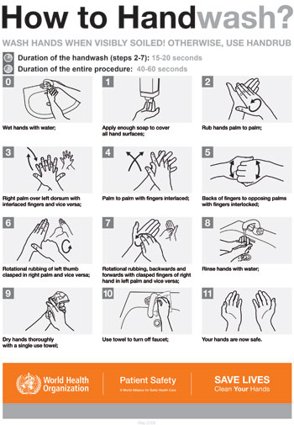
How to Hand Wash Guide

